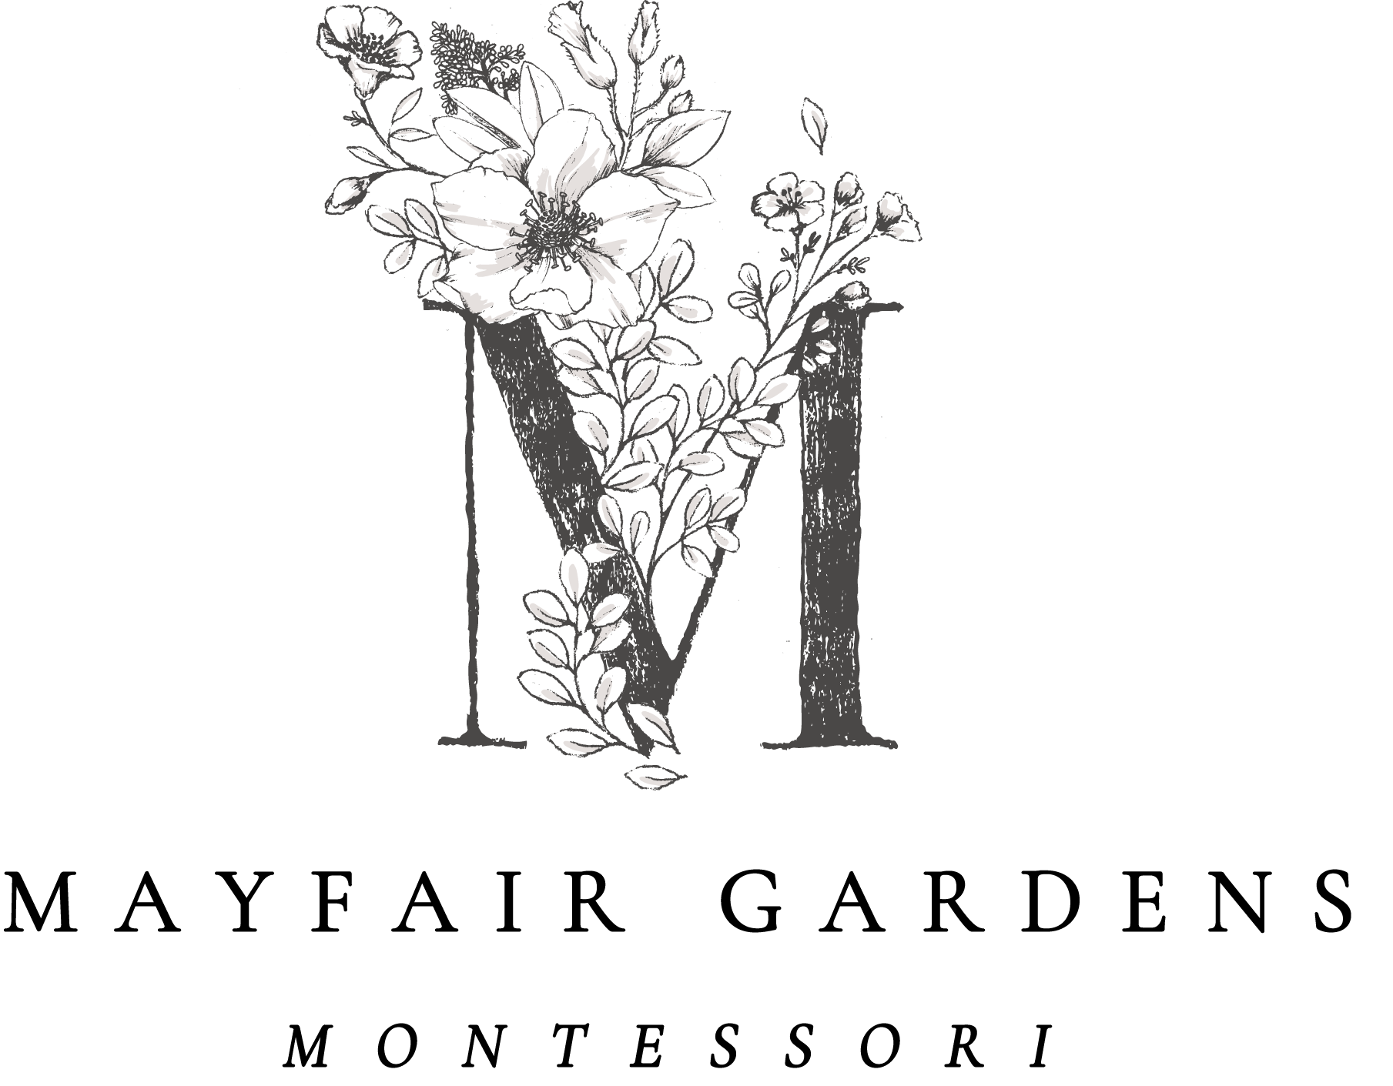

Child’s information

Last name

First name

Date of birth

Female or male

Parent’s information

Mother’s name:  Mother’s preferred title:  Mother’s profession: | Mother’s address:
Mother’s email:

Mother’s phone:

Father’s name:  Father’s preferred title:  Father’s profession: | Father’s address:
Father’s email: | Father’s phone number :

At Mayfair Gardens Montessori, we require the following prior to attending the first day of our program:

- Children must be between the ages of 2.5 and 5 by September 1st.
- Children must be immunized by September 1st.
- Children must be toilet-trained by the first day of the program.

For the following questions, please answer “yes” or “no” and feel free to add comments if necessary.

- Will your child be between the ages of 2.5 and 5 by September 1st?

- Do you agree to have your child immunized and share those records by September 1st?

- Is your child toilet-trained?

We offer a 3, 4, or 5 day option. How many days will you require?

Finally, we would love to know a bit more about your child! Has s/he had any prior out-of-home learning experiences, i.e. prior daycare, preschool, Montessori, etc.?

Thank you so much for completing the admissions application!
Please scan and email to: admissions@themayfairgardens.org
Application fee of $50.00 can be mailed to our attention:
20 Milton Street, Williamsville, New York 14221

